Mr Till Häussner
thaeussner@ethz.ch
+41 787551040

Mr Gian Teufen
teufeng@ethz.ch
+41 764213122

Global Health Engineering Group
at the department of Mechanical and Process Engineering ETH Zurich, CLD D12
8092 Zurich, Switzerland

27 July 2025

Re: NCRSH Ethics Application
To Whom It May Concern:
We are pleased to submit the research proposal entitled “Data Collection on Energy Systems and Medical Devices in Healthcare Facilities in Malawi” for ethical review.
The field work will begin in August 2025 and will address the current state of energy supplies, medical devices and equipment in healthcare facilities throughout Malawi.
All documents required for submission, as presented in the checklist are included in this application.
Thank you for considering this application.
Sincerely,
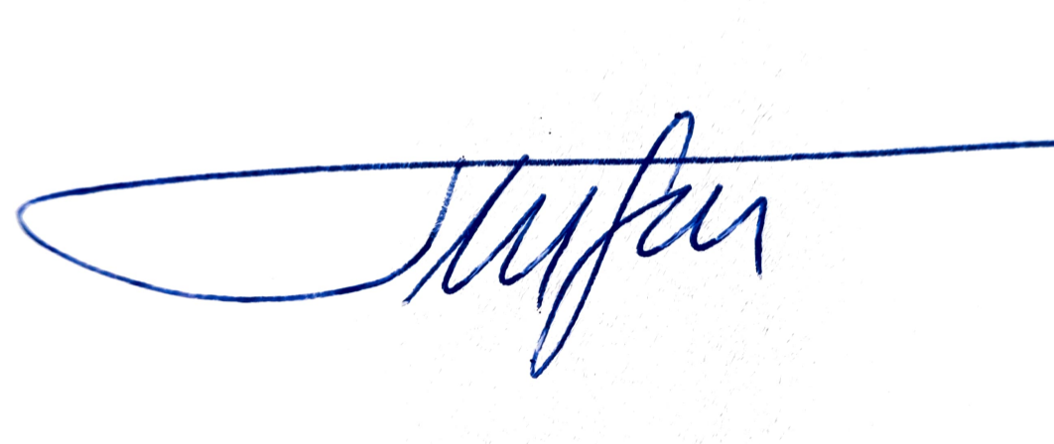
Till Häussner & Gian Teufen

Data Collection on Energy Systems and Medical Devices in Healthcare Facilities in Malawi

Principal Investigators (PI)
Name | Title | Group/Chair/Institute | University
Gian Teufen | Mr. | Global Health Engineering | ETH Zurich
Till Häussner | Mr. | Global Health Engineering | ETH Zurich

Involved Researchers
Name | Title | Group/Chair/Institute | University
Frank Mnthambala | Dr. | Agrisciences Department | Mzuzu University
Hope Kelvin Chilunga | Mr. | Department of Computer Science and Information Technology | Malawi University of Business and Applied Science
Rebecca Alcock | Dr. | Global Health Engineering, Center for Global Engineering | ETH Zurich, University of Toronto
Elizabeth Tilley | Prof. Dr. | Global Health Engineering | ETH Zurich
Jakub Tkaczuk | Dr. | Global Health Engineering | ETH Zurich

Summary
Study Objective: This study aims to address the critical issue of energy access in Malawi's healthcare facilities (HCF). The objective is to collect detailed facility-level data on power supply status, including energy source mix, energy storage, and outage preparation. It will also document the origins and current operations and maintenance (O&M) structures of energy systems and key medical devices. The goal is to create a dataset that enables accountability among stakeholders and provides insights into the successes and failures of current energy systems. Further, data on the medical devices, amenities and equipment present will be collected for better energy load estimations and an updated estimation of the service readiness indicators and index as part of the SARA evaluation tool by WHO. These data will aim to inform decision-making and help prioritize interventions for improving energy access and quality of care in Malawi's HCF.
Methods: Data collection involves field visits of 2-3 HCF per week. Data will be collected through semi-structured questionnaires and observations.
Participants: HCF administrators, management and responsible persons.
Potential risks: The interview might pose a time burden for participants.
Conclusion: This research will generate a detailed dataset on energy access, O&M, medical devices and basic service readiness in Malawian healthcare facilities, addressing a critical information gap. The findings will offer insights into power system functionality and maintenance, as well as more accurate energy load estimations, informing strategic decisions to improve energy access in HCF. This study also aims to enhance stakeholder accountability and strengthen healthcare delivery across Malawi.

1.Background and literature review
Even though the importance of energizing HCF seems natural, data on the topic remains scarce and fragmented (SETI, 2018). This consequently limits the ability of governments, development partners, and service planners to make informed decisions, track progress, or prioritize interventions effectively. The majority of studies to address energy access have focused primarily on household settings, while comprehensive data on healthcare facilities remain limited (Jeuland et al., 2021; SETI, 2018). Work on energizing HCF in Africa is especially rare. Indeed, several African nations do not appear to have a single quantitative peer-reviewed study that investigates an energy-related question (Jeuland et al., 2021). In sub-Saharan Africa, one in four HCF operates entirely without electricity, most of them are located in rural areas. Of the ones that have electricity, three-quarters do not have reliable power supply (Adair-Rohani et al., 2013; Moner-Girona et al., 2021).
Of HCFs in Malawi, 72% have grid access, 21% had other electricity sources such as solar and 7.1% have no access to any electricity at all. The latter are mostly primary-level facilities, particularly rural health posts (World Bank et al., 2023). But access still comes with frequent blackouts disrupting service delivery (Reuland et al., 2020). While renewable energy systems like solar photovoltaic (PV) have been implemented, many are insufficient in capacity and suffer from substandard installation or lack proper maintenance, failing to meet the full energy demands of facilities and leading to frequent load disconnects (UNICEF, 2018). Poor maintenance leads to frequent breakdowns and repairs are often delayed, primarily due to insufficient maintenance staff, supplies, backup energy sources and funding (Franco et al., 2017, p. 20; Shadvar & Rahman, 2024). Load management in Malawian healthcare facilities has not been well addressed, with installations frequently failing to sufficiently consider electrical loads, their distribution, or appliance efficiencies, which results in frequent load disconnects, energy not being matched to priority needs and lower functionality of medical equipment (Ngongoma et al., 2025; Suhlrie et al., 2018).

Problem Statement
Few studies exist that gather detailed data on power systems, electrical loads, devices and appliances in HCFs in rural Malawi. This hinders governments, development partners, energy engineers and service planners from making data-informed decisions, tracking progress and prioritizing interventions.
A large percentage of power systems and medical devices come from donations. Sometimes the approach to donations seems to be that the upfront financing and short-term O&M are covered, while the facilities are expected to cover long-term costs and responsibility without sufficient institutional or governmental support.
These problems are most prevalent in rural areas, in facilities that provide primary care level services. This includes health posts, dispensaries, maternity clinics, health centers and community hospitals. Primary level facilities account for over 90% of Malawi’s health system (World Bank Group, 2019).

Justification
The study contributes to the growing body of literature on energy access planning in healthcare by being the first to analyze the availability, functionality, regional variation, and management of power systems, alongside the general service readiness, in Malawian healthcare facilities (HCF).
This also provides an opportunity to pilot the proposed SARA energy module (WHO and World Bank, 2015), allowing us to refine and validate this standardized survey tool for measuring energy access in healthcare facilities. Through the pilot phase, we will identify whether we can successfully combine the gathered information into meaningful indicators like the multi-tier electricity access framework and the Index of Electricity Access in Health Clinics (WHO and World Bank, 2015)
The dataset and the resulting policy white paper that provides an overview of successes and failures, offer valuable insights into landscape of ownership, deployment, and maintenance responsibilities and offers a strategy for improving accountability among stakeholders would be valuable for the sector.

Project

Study Objective

Main Objectives
This study aims to collect detailed, facility-level data on power supply status but also on the origins and current O&M structure of energy systems and further take inventory of medical devices and electrical appliances and amenities present. This data will then be used to draw up a policy white paper that provides an overview of successes and failures and offers a strategy for improving accountability among stakeholders moving forward.

Specific Research Questions
- What proportion of healthcare facilities in Malawi have functioning energy systems, and what types of primary and backup energy sources, energy storage, and outage protection are currently in place?
- Among energy systems and medical devices, what percentage remain functional, and which stakeholders are accountable for their deployment, ownership, and ongoing maintenance?
- How do the characteristics of power systems (e.g., energy source mix, functionality, maintenance) differ by region, catchment population size, and associated donors or implementing partners?
- Does the HCF have an established plan to reduce or reorganize their loads if not all demand can be met?
- What is the estimated service readiness index as defined by SARA of WHO for the facilities?
- How does the energy situation of facilities correlate with their overall service readiness index?
- Is there already a noticeable influence of climate change on the operations in HCFs?
- What medical devices and electrical appliances are present in HCFs and what are their characteristics, functionality and actual power consumption?
- How can energy loads be estimated based on the electrical devices present and their power consumption?

Hypothesis
- A majority of primary care facilities in Malawi lack consistent access to functioning power systems, relying primarily on the national grid or solar energy installations as the main sources and diesel or petrol generators as backup, with limited energy storage capacity and minimal outage protection mechanisms.
- A substantial portion of installed energy systems and essential medical devices in Malawi’s primary care facilities are either damaged or broken, due to O&M difficulties.
- Using detailed device information and measured power consumption values, electrical loads of the facilities can be estimated more accurately than using standard values from literature.
- Power system characteristics vary significantly across regions and stakeholders.
- Most HCFs do not have a formalized load management plan in place, resulting in the inability to prioritize critical loads during power shortages.
- HCFs with greater access to reliable and adequate energy will exhibit higher overall service readiness.
- Climate change is already having a noticeable impact on the operations of healthcare facilities in Malawi, primarily through increased frequency of power outages, heat-related strain on staff and patients, though we suspect staff do not necessarily make a direct connection between these realities and climate change

Methods and Study Design

Method of data collection

Inspection
Qualitative and Quantitative data will be collected on various characteristics of power supply status, including the energy source/storage mix, nameplate characteristics and outage preparation and protection. Accessing this information will require talking to a responsible person; however, the collecting of nameplate characteristics and other related energy metrics can be conducted by the PI without additional support once pointed in the right direction. Categories are based and combined on the ones provided by various sources to ensure full coverage and international compatibility (WHO, 2015a; Ngongoma et al., 2025; Reuland et al., 2020; Suhlrie et al., 2018).
Photographic documentation of energy system components and medical equipment on facility premises will be conducted. These images will solely capture equipment status and will strictly exclude any identifiable individuals or patient information.

Structured Questionnaire
The questionnaire is composed of these sections:
- Facility Identifiers
- Energy System
- Origins, Operations and Maintenance
- Climate Change & Weather Impact
- Amenities & Equipment

In section zero the facility identifiers are collected. This includes information on location, facility type, managing authority and patient count.
Section one is the entirety of the “SARA energy module: sample survey questions for multi-tier measurement” proposed in 2015 (WHO and World Bank, 2015). It was specifically designed to ensure that all the questions needed for international analyses are covered. It includes all of the energy related questions proposed in the harmonized health facility assessment (HHFA) (WHO, 2023) but offers additional more in-depth questions about electric capacity, evening supply, financing and more. This study also serves as a pilot for the module and an according review of the experience with it will be included in the report.
In the second section, extensive qualitative data is collected on current O&M practices, the original project structure and financing mechanisms of the power supply.
The third section explores the connection between climate change and HCF. Whether there has already been any occurrence of extreme weather conditions and consequently other noticeable changes in operations or patient population.
The fourth section covers the questions needed to determine the general service readiness indicator as proposed by SARA (WHO, 2015). This involves assessing five key domains: basic amenities, basic equipment, standard precautions for infection prevention, diagnostic capacity, and essential medicines. Each of those indicators is given a score based on reported availability, out of which the main index score is calculated, ensuring a holistic evaluation of a health facility's fundamental operational capabilities.
The full questionnaire is provided in Appendix 3.

Study Design

Study Site
The planned location timeline for the thesis is in the order north, south and central, with a one-month stay each in Mzuzu, Blantyre and Lilongwe. Per week, about 2-3 health posts will be visited and the device inventory will be logged. Planning for the individual facility visits will be done later in Malawi to account for schedule changes and anything unforeseen.

Study Visits
Study visits will be announced in collaboration with the respective DHOs in advance. On arrival, all staff and patients present will be informed about the study using a quick oral presentation and the written handouts in both English and Chichewa (Appendix 1).
Participants will then be recruited for the questionnaire and will sign the information and consent form (Appendix 2).
The medical device and electrical appliance inventory will be studied by the researchers themselves with help of staff without a dedicated questionnaire. Details on devices will include name, brand, type, nameplate energy characteristics and functionality. Pictures of devices will be taken and device power consumption will be measured using standard household energy loggers. This will be done as nonobstructive as possible to minimize negative impact on facility workings and healthcare provisions. Management staff and participants will at any point be able to pause or stop the research in the facility without giving any reason or receiving any disadvantages to always ensure proper facility workings.

Participants for Questionnaire

Number of Participants
Per facility, 1-2 knowledgeable persons will be questioned on-site. With an estimated 40 facilities to be visited this would amount to about 60 participants.

Inclusion Criteria
- Individuals who are knowledgeable about the energy system of the HCF
- Individuals aged more than 18 years
- When available, individuals who have worked on the site for more than two years

Exclusion Criteria
- Individuals who do not consent to being interviewed

Recruitment Procedure
In consultation with the respective DHOs, management and administrative contacts of the respective healthcare facilities will be identified and informed about the study. With facility management, fitting survey participants will be recruited for participation based on criteria mentioned above.

Project Timeline
The research will commence in August in facilities on northern Malawi and Mzuzu. The researchers will then move to Blantyre for September and conduct research in facilities in southern Malawi and finally conduct research in districts in central Malawi based out of Lilongwe in October.

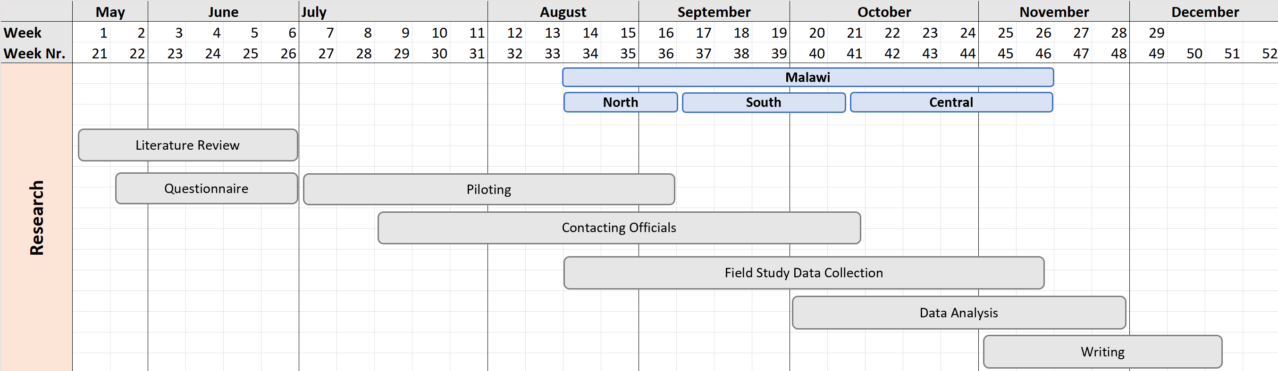

Project Partners and Funding

Source of Funding
The project is funded by the Global Health Engineering (GHE) group at ETH Zurich.

Roles and Rights of Project Collaborators
- Rebecca Alcock (Dr., Global Health Engineering, ETH Zurich; Center for Global Engineering, University of Toronto): She is the main supervisor of the thesis and will have access to the project data for providing input if needed.
- Elizabeth Tilley (Prof. Dr., Global Health Engineering, ETH Zurich): She provides overall supervision in the GHE group, with access to the project data.
- Jakub Tkaczuk (Dr., Global Health Engineering, ETH Zurich): He is the second supervisor of the thesis and will have access to the project data for providing input if needed.
- Frank Mnthambala (Dr., Agrisciences Department, Mzuzu University): He is our contact for advice in Mzuzu.
- Hope Kelvin Chilunga (Mr., Lecturer at Malawi University of Business and Applied Science): He is our contact for advice in Blantyre.

The research group GHE brings an extensive network of collaborators and experience in Malawi, having conducted numerous studies on topics of health, renewable energy, solid waste management and more within the country. This understanding of the local context and existing research helps our current study to be as nuanced and effective as possible.

Detailed Budget and Justification
Item | Unit | Cost/unit (USD) | Nr. of units | Total cost (USD) | comments
Flipcharts | Number of flipcharts | 2 | 2 | 4
Plastic Documents Sleeves | Number of plastic document sleeves | 1 | 10 | 10
Printed Info Handouts | Number of printed info handouts | 0.1 | 100 | 5 | 50 English copies and 50 Chichewa copies
Printed Consent Forms | Number of printed info & consent forms | 0.1 | 160 | 8 | 80 English copies and 80 Chichewa copies
Energy meter | Number of Energy Meters | 60 | 2 | 120
SD cards | Number of SD Cards | 20 | 3 | 60
Car | Number of months renting the car | 500 | 4 | 2000
Gas | Number of months | 500 | 4 | 2000
PPE Masks | Number of masks | 1 | 20 | 20
Disinfection bottles for health posts | Number of disinfection bottles | 2 | 50 | 100
 |  |  | Total cost (USD | 4327
Ethics Application |  |  | 10% of total cost (USD) | 433
 |  |  | Total project cost (USD) | 4760

Ethical Aspects

Informed Consent and Debriefing

Recruitment of Participants
With the approval of the Malawian “National Committee On Research In The Social Sciences” (NCRSH), the district health offices (DHO) will be individually contacted, informed about the contents of our study and asked for contacts to facility administrators in their respective districts. With them we will communicate in advance and schedule an appropriate date for us to visit. They will be asked to sign the consent form before the interview.

Dissemination of Study Information
Detailed study information will be sent in advance to each DHO and facility in the form of this ethics application. Each participant will also be explained the structure of the interview individually by briefing the consent form in Appendix 2. Information sheets (Appendix 1) about the study will be posted in the facilities in both English and Chichewa for other people present.

Expression of Informed Consent
Participants will express their informed consent by signing the consent sheet (Appendix 2). The research team will work with the facility administrator to ensure compliance with ethical guidelines, and the participant gets to keep a copy of the consent form.

Storage of Consent Forms
The consent forms will be retained by the GHE group for 5 years for record-keeping and verification. These will be stored in a locked cabinet. Only Prof. Dr. Tilley will have access to the keys.

Consent for Illiterate Participants
For participants who are illiterate, informed consent will be recorded using a fingerprint. A witness will be present to verify and record the consent.

Sharing Study Results
As soon as everything is digitized, the data collected of each individual facility will be sent to the facility administrator and relevant facility data to the corresponding DHO. Once the thesis is completed and published to the ETH research collection the report will be sent to each DHO and facility.

Data Protection and Publication

Data Collection
Individuals participate anonymously. No personal data will be collected. The data will only be affiliated with the facility. Study questionnaire data will be collected digitally into tablets/smartphones using (KOBO Toolbox) software.

Data Storage
Consent forms and any other paper documents will be stored in a locked cabinet in the study office. Only the project lead and Prof. Tilley from the Global Health Engineering research group will have access to these documents.
Study tablets/smartphones will be backed up to a study PC and data deleted from the handheld devices every alternate day. Data will be backed up to the ETH internal server for storage.

Data Analysis
R Statistical Software and RStudio IDE will be used for quantitative data analysis to generate the results in the manuscript. The raw as well as the aggregated processed data will be published as an R package. Individual participants cannot be identified. The analysis code that will be used to generate the figures and tables of the manuscript will be contained in a public GitHub repository.

Anonymization
All data will be completely anonymous to the facility level, instead of individual level.

Publication of Results
- Forms: Results will be published in research papers, blogs, and policy briefs to disseminate findings widely and inform both scientific and public communities.
- Accessibility: Data will be made accessible in an anonymous form, such as through a repository, to allow for further research and verification.

Compensation
Participants will not receive monetary compensation for their participation in the study.

Risk and Discomforts
Participating in the study entails no physical or psychological risks or discomforts. The interview might pose a time burden for participants. If participants wish to interrupt the interview, they can do so at any time. There are also no social or environmental risks in the future.

Ethics Reviews by funding institution ETH Zurich
The questionnaire was approved by the Ethics Commission of ETH with number 25 ETHICS-206. The data collection on the medical device and appliance inventory was given a separate waiver with number EK-2025-E-19. Both documents are available on request.

4. References
Adair-Rohani, H., Zukor, K., Bonjour, S., Wilburn, S., Kuesel, A. C., Hebert, R., & Fletcher, E. R. (2013). Limited electricity access in health facilities of sub-Saharan Africa: A systematic review of data on electricity access, sources, and reliability. Global Health: Science and Practice, 1(2), 249–261. https://doi.org/10.9745/GHSP-D-13-00037
Franco, A., Shaker, M., Kalubi, D., & Hostettler, S. (2017). A review of sustainable energy access and technologies for healthcare facilities in the Global South. Sustainable Energy Technologies and Assessments, 22, 92–105. https://doi.org/10.1016/j.seta.2017.02.022
Jeuland, M., Fetter, T. R., Li, Y., Pattanayak, S. K., Usmani, F., Bluffstone, R. A., Chávez, C., Girardeau, H., Hassen, S., Jagger, P., Jaime, M. M., Karumba, M., Köhlin, G., Lenz, L., Litzow, E. L., Masatsugu, L., Naranjo, M. A., Peters, J., Qin, P., … Toman, M. (2021). Is energy the golden thread? A systematic review of the impacts of modern and traditional energy use in low- and middle-income countries. Renewable and Sustainable Energy Reviews, 135, 110406. https://doi.org/10.1016/j.rser.2020.110406
Moner-Girona, M., Kakoulaki, G., Falchetta, G., Weiss, D. J., & Taylor, N. (2021). Achieving universal electrification of rural healthcare facilities in sub-Saharan Africa with decentralized renewable energy technologies. Joule, 5(10), 2687–2714. https://doi.org/10.1016/j.joule.2021.09.010
Ngongoma, L., Xing, A., Wang, J., Zhang, C. R., Twea, P., Chiwanda, J., Weiner, B., & Su, Y. (2025). Power Supply and Ultrasound Functionality in Malawi: Findings from the 2019 Harmonized Health Facility Assessment (HHFA). Research Square. https://doi.org/10.21203/rs.3.rs-6554481/v1
Reuland, F., Behnke, N., Cronk, R., McCord, R., Fisher, M., Abebe, L., Suhlrie, L., Joca, L., Mofolo, I., Kafanikhale, H., Mmodzi Tseka, J., Rehfuess, E., Tomaro, J., Hoffman, I., & Bartram, J. (2020). Energy access in Malawian healthcare facilities: Consequences for health service delivery and environmental health conditions. Health Policy and Planning, 35(2), 142–152. https://doi.org/10.1093/heapol/czz118
SETI. (2018). Sustainable Energy Transitions. Energy as the Golden Thread: What do we Know? (James E. Rogers Energy Access Project). https://energyaccess.duke.edu/energy-as-the-golden-thread-what-do-we-know/
Shadvar, S., & Rahman, A. (2024). Performance evaluation of off-grid solar systems for critical medical instruments in remote regions. Journal of Emerging Science and Engineering, 2(2), Article 2. https://doi.org/10.61435/jese.2024.e22
Suhlrie, L., Bartram, J., Burns, J., Joca, L., Tomaro, J., & Rehfuess, E. (2018). The role of energy in health facilities: A conceptual framework and complementary data assessment in Malawi. PLOS ONE, 13(7), e0200261. https://doi.org/10.1371/journal.pone.0200261
UNICEF. (2018, December 1). Energy needs assessment of Malawi’s health sector | UNICEF Malawi. https://www.unicef.org/malawi/reports/energy-needs-assessment-malawis-health-sector
WHO. (2015a). Access to modern energy services for health facilities in resource-constrained settings. https://www.who.int/publications/i/item/9789241507646
WHO. (2015b). Service Availability and Readiness Assessment (SARA). https://iris.who.int/bitstream/handle/10665/149025/WHO_HIS_HSI_2014.5_eng.pdf
WHO. (2023). Harmonized Health Facility Assessment (HHFA) [Version 2.1]. https://www.who.int/data/data-collection-tools/harmonized-health-facility-assessment/questionnaires
WHO and World Bank. (2015). Access to modern energy services for health facilities in resource-constrained settings: A review of status, significance, challenges and measurement. Access to Modern Energy Services for Health Facilities in Resource-Constrained Settings: A Review of Status, Significance, Challenges and Measurement, 102–102.
World Bank Group. (2019). Malawi—Harmonized Health Facility Assessment: 2018-2019 Report (Vol. 1 of 4): Main Report (English). Washington, D.C.
World Bank, UN, & National Statistical Office. (2023). Malawi; Energy Access By Institutions, Businesses and Communities Report.

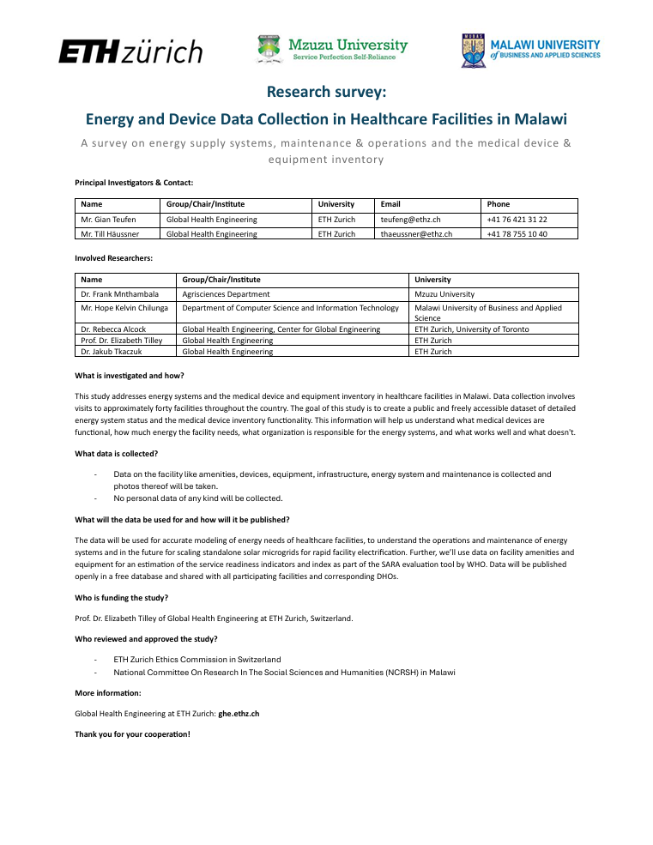
Appendix 1a: Facility Info Sheet English
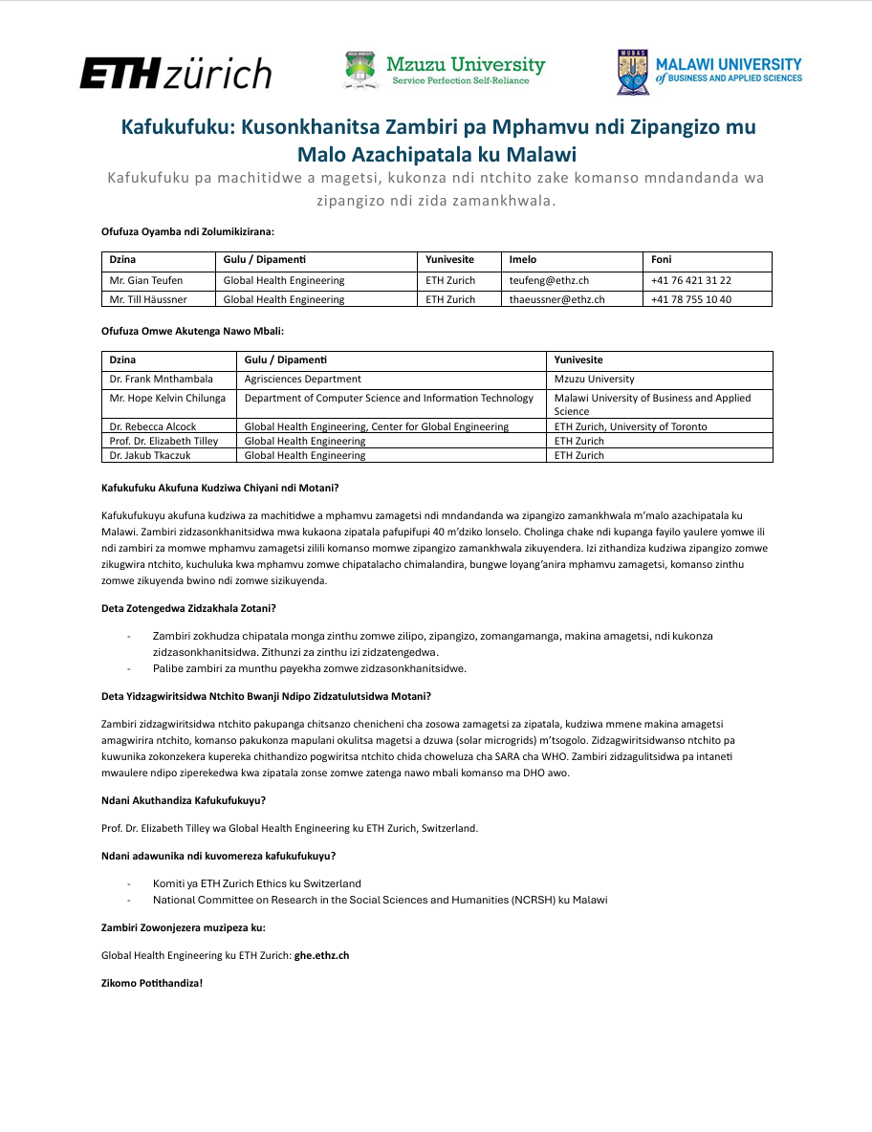
Appendix 1b: Facility Info Sheet Chichewa
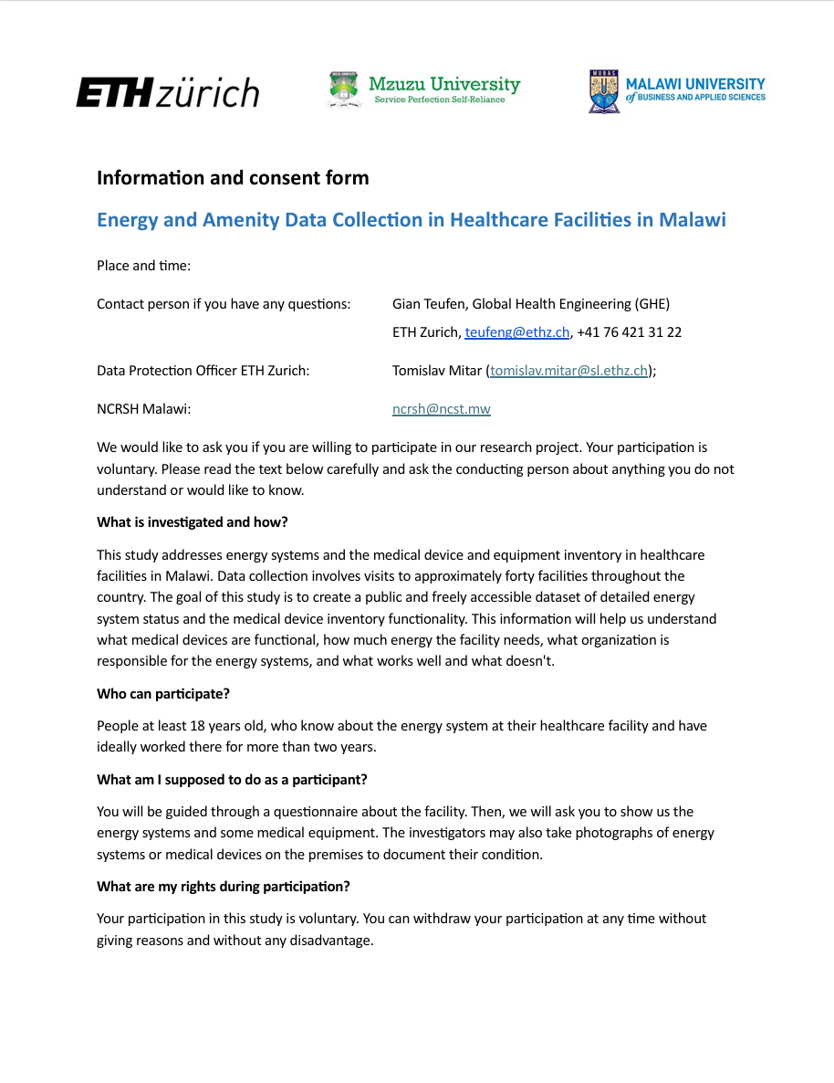
Appendix 2a: Consent Form English
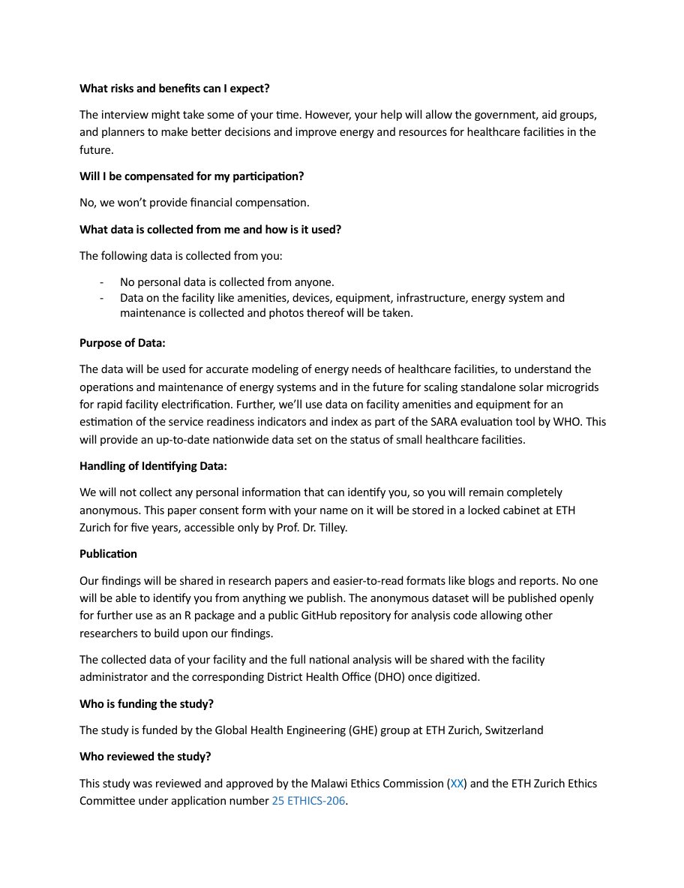
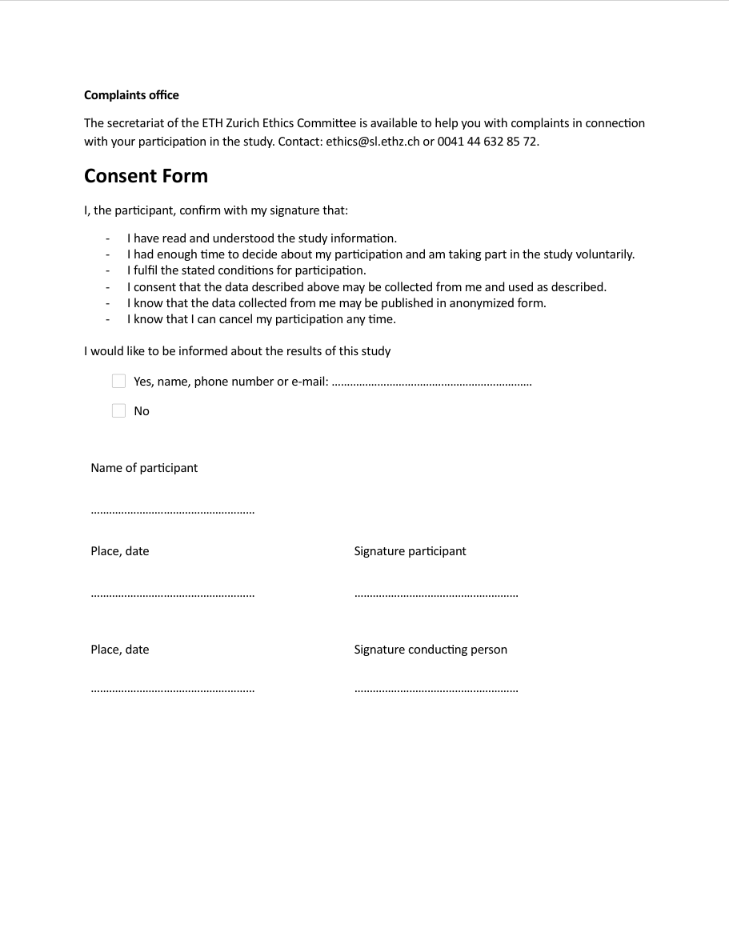
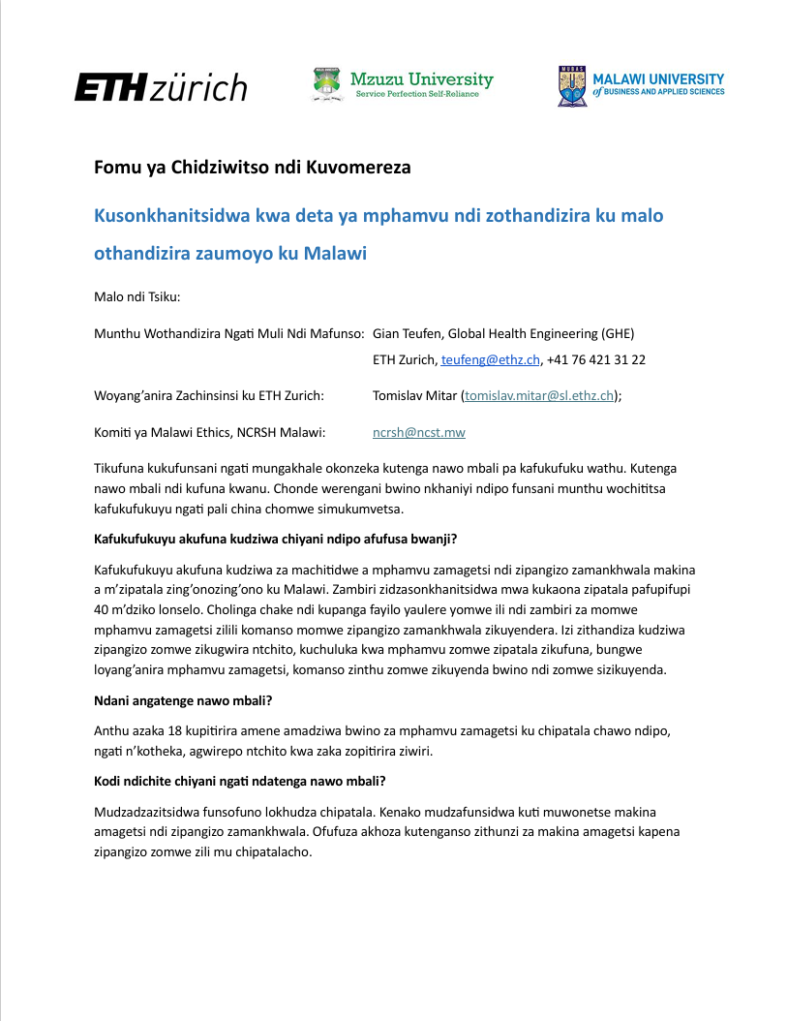
Appendix 2b: Consent Form Chichewa
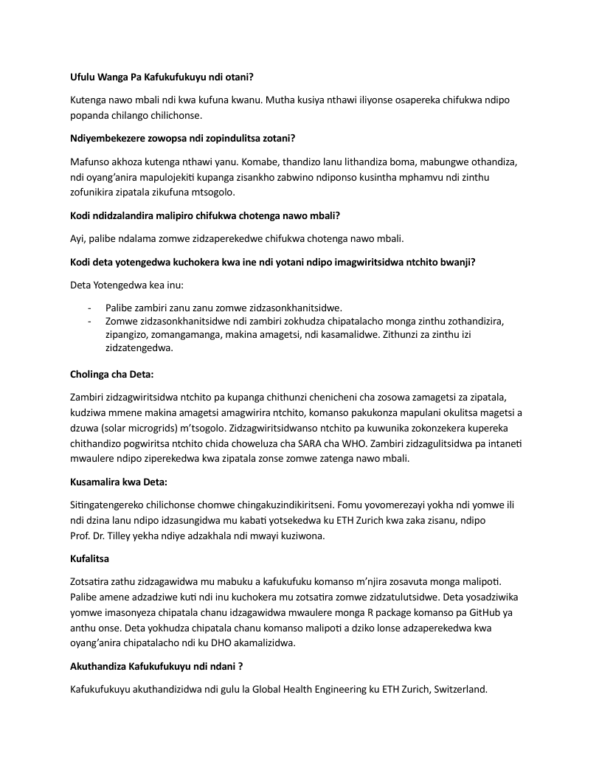
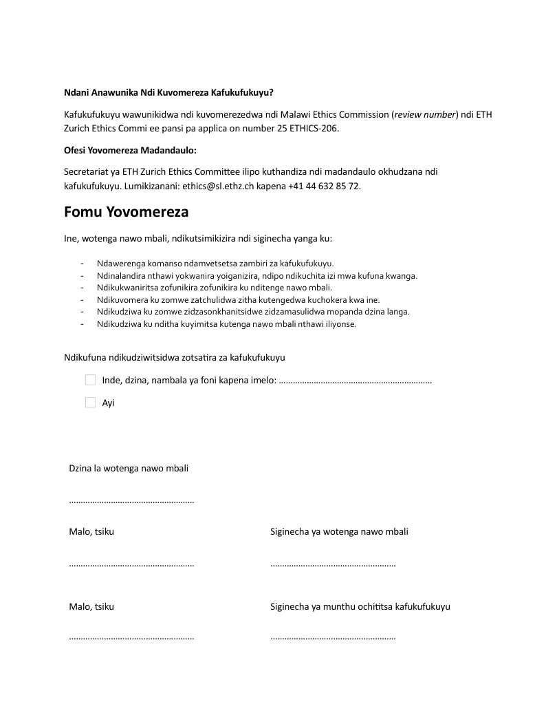
Appendix 3a: Questionnaire English

English
Facility Identifiers
Question | Logic | Choices
What is the name of the facility? |  | [Free text]
What is the address or description of the facility location? |  | [Free text]
Elevation (m) |  | __ __ __ __
Latitude |  | N/S __  DEGREES __ __  DECIMAL __ __ __ __
Longitude |  | N/S __  DEGREES __ __  DECIMAL __ __ __ __
In which region/province is the facility located? |  | North  Central  South
In which district is the facility located? |  | [List of all districts]
What type of facility is this? |  | National referral hospital  District/Provincial hospital  Health centre/clinic  Health post  Maternal/child health clinic  Other (specify)
What is the managing authority of the facility? |  | Government/Public  NGO/Not-for-profit  Private-for-profit  Mission/faith-based  Other (specify)
Is the facility located in an urban or rural area? |  | Urban  Rural
Is the facility outpatient only? |  | Yes  No  Don’t know
On average, how many patients visit the facility per day? |  | 0  1-10  11-20  21-50  51-100  >100
On average, how many patients visit the facility per week? |  | 0  1-50  51-100  101-200  201-500  >500
Which days of the week is the facility open to patients? | Check all that apply | Monday  Tuesday  Wednesday  Thursday  Friday  Saturday  Sunday
Which days are the busiest per week on average? | Check all that apply | Monday  Tuesday  Wednesday  Thursday  Friday  Saturday  Sunday
How long do outpatients stay in the clinic? |  | <1 hour  1-2 hours  2-4 hours  4-6 hours  >6 hours  Don’t know
How long is the average consultation? |  | <5 minutes  5-15 minutes  15-30 minutes  30-60 minutes  >60 minutes  Don’t know
How do patients get to the clinic? | Check all that apply | Foot  Bicycle  Car (private/taxi)  Bus (public transport)  Shuttle (facility-provided)  Other (specify)
How does the patient population vary over the year? Is there a busy season/which season is the busiest? | Check all that apply | Hot & Wet Season (November - April)  Cool & Dry Season (May - August)  Hot & Dry Season (September - October)  No significant variation

Energy System; SARA Energy Module (WHO, 2015)
Question | Logic | Choices
Questions on capacity
Does your facility have electricity from any source (e.g. grid, generator, solar, or other)? | Skip | Yes  No
What is the electricity used for in the facility? | ${electricity} = ‘no’  Check all that apply | Only stand-alone electric medical devices/appliances (e.g. EPUI cold room, suction apparatus, refrigerator, etc.)  Electric lighting (excluding flashlights) and communications  Electric lighting, communications, and 1 to 2 medical devices/appliances  All electrical needs of the facility  All electrical needs of the facility and staff housing
If the facility has no electricity, what is its primary lighting source? | Check all that apply | No source of lighting  Kerosene lamps  Candles  Battery-operated lamps/flashlights  Solar lanterns  Headlamps  Other (Specify)
If the facility has electricity, what is its main source? Note: This means the electricity source that you rely upon most of the time. | ${electricity} = ‘yes’ | Central supply (national/community grid)  Local mini-grid (i.e., the facility shares electricity supply, typically a renewable source or a generator, with other nearby buildings) Specify the supply modality if known.  On-site hybrid solar/generator  On-site generator (with battery storage)  On-site generator (no battery storage)  On-site solar system (except lanterns)  Dedicated hydropower system  Dedicated wind power system  Other (Specify)
Does the facility have an energy storage system like a rechargeable battery system? |  | Yes  No  Don’t know
Other than the main or primary source, does the facility have a backup source of electricity? If so, what is the secondary source of electricity? | ${electricity} = ‘yes’  Check all that apply | No back-up source  Central supply electricity grid  Local mini-grid (i.e., the facility shares electricity supply, typically a renewable source or a generator, with other nearby buildings) Specify the supply modality if known.  On-site generator (with battery storage)  On-site generator (no battery storage)  On-site solar system (except lanterns)  Dedicated hydropower system  Dedicated wind power system  Solar lanterns  Other (Specify)
If you have both a primary and a secondary/backup source, do you have an energy management system to switch automatically? | ${secondary} = ‘yes’ | Yes, automatic shift, with fuel efficiency optimization (for example with the wind/solar)  Yes, automatic shift; but no efficiency optimization  No, a manual startup is needed
If you have no backup electricity source, what is your backup lighting source? | ${secondary} = ‘no’ | No back-up source of lighting  Kerosene lamps  Candles  Battery-operated lamps/flashlights  Headlamps  Solar lanterns  Other (Specify)
Generator Functionality
Does the generator have a charged battery available today? | selected(${generator}) | Yes  No  Don’t know
Does the generator have fuel available today? | selected(${generator}) | Yes  Petrol  Diesel  No  Don't know
Solar System Functionality
Is the solar system functional? | selected(${solar}) | Yes, functioning as expected  Partially  Battery needs servicing or replacement  Specify all parts  No, not functional  Don’t know
For how many hours per day, on average, does the solar system provide power? | selected(${solar}) | 4 hours or less  5 to 8 hours  9 to 16 hours  17 to 23 hours (energy storage system required)  24 hours (energy storage system required)
Duration
On average, how many hours per day is this facility open? |  | 4 hours or less  5 to 8 hours  9 to 16 hours  17 to 23 hours  24 hours
On average, for how many hours in a 24-hour day is electricity available should you need to use it? |  | 4 hours or less  5 to 8 hours  9 to 16 hours  17 to 23 hours  24 hours
Evening supply
On average, for how many hours during the evening (after 6 p.m.) and night is the facility open for services? |  | Never open after 6 p.m  Until 8 p.m  Until 10 p.m.  Until midnight  All night long
On average, for how many hours during the evening (after 6 p.m.) and night is electricity available at the health facility? |  | Less than 1 hour  1 to 2 hours  3 to 4 hours  5 to 8 hours  8 to 14 hours
Reliability
During the past 7 days, was electricity available at all times when it was needed from the main or any backup source when the facility was open for regular or emergency services? |  | Always available (no interruptions)  Often available (some interruptions of less than 2 hours per day)  Sometimes available (frequent or prolonged interruptions of more  than 2 hours per day)
If connected to the grid, on an average day, how many times does the facility face electricity supply interruptions from the grid? |  | No interruptions  1-3 interruptions per day  More than 3 interruptions per day
If primarily using on-site generation, on an average day, how many times does the facility face electricity supply interruptions? |  | No interruptions  1-3 interruptions per day  More than 3 interruptions per day
On an average day, what is the total duration of all supply interruptions taken together? |  | No interruptions  Less than 30 min  31-60 min  61 min to 4 hours  5-8 hours  More than 8 hours
When are supply interruptions most common? |  | Daytime (before dark)  Evening (after dark to midnight)  Overnight (midnight to 8 a.m.)
Quality
Does the facility usually face a problem of low voltage or voltage fluctuations from the main source? |  | Yes  No  Don’t know
Have voltage fluctuations damaged equipment in the past year? |  | No  Some equipment damaged  Significant equipment damaged
Financial Sustainability
If you use electricity from the grid, did you have sufficient budgetary allocation (funds available) for paying your electricity bills in the last two months? | selected(${grid}) | Yes  No  Don’t know  Not applicable
If you use electricity from the grid, who pays the electricity bill for the health clinic? | Check all that apply | Ministry of Health/district health office  Donor  Health facility  Combined funds from donor, facility, ministry  Patients  Don’t know
Over the last two months, did you have sufficient budgetary allocation (funds available) for fuel for the stand-alone generator to operate at all times when it was needed? | selected(${generator}) | Yes  No  Don’t know
Who pays for generator fuel? | selected(${generator})  Check all that apply | Ministry of Health/district health office  Donor  Health facility  Combined funds from donor, facility, ministry  All electricity is metered and billed to patients  Some electricity is billed to patients  Don’t know
Over the last year, did you have sufficient budgetary allocation (funds available) to keep the solar panels functional? | selected(${solar}) | Yes  No  Don’t know
If you use a solar energy-based electricity solution, who pays for light bulbs and solar parts replacement? | selected(${solar})  Check all that apply | Ministry of Health/district health office  Donor  Health facility  Patients  Combination of facility, ministry, donor sources  Private payments by staff or patients  Combination of private purchases and other sources  No one  Don’t know
Over the last two months, did you have sufficient budgetary allocation (funds available) for maintenance of electricity supply equipment? | ${electricity} = ‘yes’ | Yes  No  Don’t know
Environmental Sustainability
Does your primary source of lighting (including kerosene lamps or candles) or electricity cause any pollution of air in the local area in or around the health clinic, through production of fumes or gases that potentially harm the health of the patients or the health workers? |  | Yes  No  Don’t know
Does your primary source of lighting or electricity cause any pollution of water or soil in the local area in or around the health clinic, through improperly discharged oils, exhausts or other pollutants that potentially harm the health of the patients or the health workers? |  | Yes  No  Don’t know
Does your primary source of electricity cause any significant noise pollution in the local area in or around the health clinic that potentially harms the health of the patients or the health workers? |  | Yes  No  Don’t know

Origins, Operations and Maintenance
Question | Logic | Choices
Origins | ${electricity} = ‘yes’
Who financed the original installation of the primary energy system at the facility? |  | Ministry of Health/district health office  Christian Health Association  Donor  Health facility  Combined funds from donor, facility, ministry  Private payments by staff or patients  Community  Other (Specify)  Don’t know  Not applicable
Who installed the primary energy system? |  | Health ministry workers  Christian Health Association  Donor  Health facility staff  Collaboration of donor & ministry  Private contractor  Community  Other (Specify)  Don’t know  Not applicable
Maintenance (preventive) | ${electricity} = ‘yes’
Is preventive maintenance carried out for the energy systems?  Preventive maintenance means the service is carried out even when there is no problem with the system. |  | Routinely  Sometimes but not routinely  Never  Not applicable
Is there a maintenance schedule for the energy system? |  | Yes  No  Don't know
Are maintenance records kept? |  | Yes, paper records  Yes, digital records  No  Don’t know
Is there a service or maintenance contract in place for the energy system? |  | Yes  No  Don't know
Is the system under warranty? |  | Yes  No  Don't know
Who carries out the preventive maintenance for the energy systems? | Check all that apply | Designated facility maintenance staff  Technicians from district or regional offices  Technicians from Christian Health Association  Donor  Private contractor  Other (Specify)  Don’t know  Not applicable
When was the energy system last serviced or maintained? |  | Within the past 3 months  3–6 months ago  More than 6 months ago  Never  Don't know
Monitoring (predictive) | ${electricity} = ‘yes’
Is any part of the energy system remotely monitored? |  | Yes  No  Don’t know
What is remotely monitored? | ${remote} = ‘yes’  Check all that apply | Central supply (national/community grid)  Local mini-grid  On-site hybrid solar/generator  On-site generator (with battery storage)  On-site generator (no battery storage)  On-site solar system (except lanterns)  Dedicated hydropower system  Dedicated wind power system  Rechargeable battery system  Solar lanterns  Other (Specify)
Repair (corrective) | ${electricity} = ‘yes’
Has any part of the system been damaged in the last 12 months? |  | Yes  No  Don’t know
What was damaged? | ${damage} = ‘yes’  Check all that apply | Central supply (national/community grid)  Local mini-grid  On-site hybrid solar/generator  On-site generator (with battery storage)  On-site generator (no battery storage)  On-site solar system (except lanterns)  Dedicated hydropower system  Dedicated wind power system  Rechargeable battery system  Solar lanterns  Other (Specify)
How severe was the damage? | For each selection above | Complete breakdown  Partial damage, but operational  Superficial damage
Was the damage repaired? | For each selection above | Yes  No  Don't know
Who carried out the repairs? | ${repair} = ‘yes’ | Ministry/Health Office  Christian Health Association  Donor  Health facility staff  Private contractor  Don’t know  Not applicable
How long did you have to wait for the repair? | ${repair} = ‘yes’ | Less than 24 hours  1-3 days  3-7 days  1-2 weeks  3-5 weeks  Still not functional  Don’t know
Is there a designated staff member trained in managing or troubleshooting the energy system? |  | Yes  No  Partially  Don't know
Do you have access to spare parts or replacements for the energy system? |  | Yes  No  Partially  Don't know
Suitability and Future Needs
In your opinion, is the current electricity system sufficient for your current needs? |  | Yes  No  Sometimes  Don't know
Do you expect your electricity needs to increase in the next 12 months? |  | Yes  No  Don't know
Are there plans to upgrade or expand the electricity system? |  | Yes  No  Don't know

Climate Change & Weather Impact
Question | Logic | Choices
Weather and Climate Change
Have you observed any changes in weather patterns over the past few years (e.g. stronger storms, more heat, longer dry seasons)? |  | Yes  No  Don’t know
Which of the following weather changes have been most noticeable? | ${weather} = ‘yes’ | Increased temperatures  Heatwaves  More frequent storms  Flooding  Longer dry periods  Other (specify)
How familiar are you with the concept of climate change? |  | Very familiar  Somewhat familiar  Heard of it, but not sure what it means  Not familiar at all
Based on your current knowledge, what or who is the cause of climate change? |  | Human activities (e.g. burning fossil fuels, deforestation)  Natural processes (e.g. volcanic activity, changes in solar radiation)  Both human and natural causes  Climate change is not happening  I don’t know  Other (specify)
In your opinion, is climate change affecting your community or the way health services are delivered? |  | Yes, significantly  Yes, to some extent  No  Don’t know
Facility Impact
Have changes in weather patterns (e.g., extreme heat, storms, floods) affected the operations at your facility? |  | Yes, significantly  Yes, somewhat  No  Don’t know
What parts of facility operations have been most affected by extreme weather events? |  | Electricity reliability  Water availability  Staff/patient access to the facility  Damage to buildings or equipment  Other (specify)
During or after weather events, has energy availability (e.g., outages, damage to systems) affected patient care? |  | Yes, significantly  Yes, somewhat  No  Don’t know
Patient Population Impact
During or after weather events, has there been any change in patient attendance at the facility? |  | Increase  Decrease  No change  Don’t know
Have you observed any changes in the patient population (e.g. more/less patients, more migrants, more seasonal illnesses like malaria, etc..) over the last two years? |  | Yes  No  Don’t know
In your view, which of these changes are related to weather or environmental conditions? | ${population} = ‘yes’ | Migration  Displaced persons  Not seeking care due to outages  Delayed care-seeking due to transportation issues  Increase in seasonal illnesses  Reduced ability to refer patients to other facilities  Other (specify)

Amenities & Equipment
Question | Logic | Choices
Basic Amenities
Is there a water source available? |  | Yes  No
What does the water source of the facility look like? | Check all that apply | Piped  Public tap  Standpipe  Tubewell/Borehole  Protected Dug Well  Protected Spring  Rain Water
Where is the water source located? | single-choice | Inside facility  Outside, within grounds  Outside, external  Other
Is there a separate, private consultation room available? |  | Yes  No
Can a normal conversation be held in the consultation room without being overheard? |  | Yes  No
Is there a toilet/latrine available for clients? |  | Yes  No
What does the toilet/latrine look like? | Check all that apply | Flush/pour flush to piped sewer system or septic tank or pit latrine  pit latrine (ventilated improved pit (VIP) or other) with slab  composting toilet
Are there adequate sanitation facilities available on premises for clients? |  | Yes  No
What functioning communication equipment is available? | Check all that apply | Private cell phone (only if reimbursed by facilitiy)  Facility cell phone  Other phone  SW radio
Is there a functioning facility computer available? |  | Yes  No
Does the computer have access to working internet? (day of survey) |  | Yes  No
Is there an emergency transportation vehicle available for clients? |  | Yes; facility-owned, routinely available, with fuel  Yes; access to vehicle near facility, routinely available, with fuel  No
Basic Equipment
Items observed and functioning in the main service area (usually the general outpatient department) or in the immediate vicinity where it is reasonable to assume that they can be used for the services being provided in the main service area
Adult Scale |  | Yes  No
Child Scale (250g steps min) |  | Yes  No
Thermometer |  | Yes  No
Stethoscope |  | Yes  No
Blood pressure apparatus |  | Yes  No
Light source (Spotlight/flashlight for examinations) |  | Yes  No
Standard precautions for infection prevention
How are sharps disposed of? | Check all that apply | Incinerator (functioning & fuel available)  Open burning in protected area  Dump without burning in protected area  Remove offsite with protected storage  Other  None
Are unprotected sharps observed on site? |  | Yes  No
How is infectious waste disposed of? | Check all that apply | Incinerator (functioning & fuel available)  Open burning in protected area  Dump without burning in protected area  Remove offsite with protected storage  Other  None
Is unprotected infectious waste observed on site? |  | Yes  No
Is storage for sharps observed on site? |  | Yes  No
What does the storage for sharps look like? | Check all that apply | Puncture-resistant  Rigid  Leak-resistant  Container to hold used sharps safely during collection, disposal and distruction  Material: plastic  Material: metal  Material: cardboard  Closeable  For sharps of all standard sizes  Clearly marked with intl. Biohazard warning no less than 50mm in diameter, printed in black or red on each of the front an back faces of the box  Other  None
Where was the storage for sharps observed? | Check all that apply | General OPD  HIV testing area  Surgery area  Other  None
Is there appropriate storage for infectious waste? (Waste receptacle (pedal bin) with lid and plastic bin liner) |  | Yes  No
Is there disinfectant available anywhere in the facility? (Chlorine-based or other country specific used for environmental disinfection) |  | Yes  No
Are there Single use —standard disposable or auto-disable syringes available anywhere in the facility? |  | Yes  No
Where is Soap and running water or alcohol based hand rub available in the facilitiy? | Check all that apply | General OPD  HIV testing area  Basic obstetric area  Newborn care area  Surgery area  Other  None
Where are Latex gloves available in the facilitiy? (If equivalent non latex gloves are available this is acceptable.) | Check all that apply | General OPD  HIV testing area  Basic obstetric area  Newborn care area  Surgery area  Other  None
Are there guidelines for standard precautions available anywhere in the facility? |  | Yes  No
Diagnostic capacity
Able to conduct the test onsite (in the facility) and functioning equipment and reagents needed to conduct the test are observed onsite on the day of the survey. These may be in a laboratory or in the service area where the test is conducted.
Haemoglobin (This may include colorimeter OR haemoglobinometer OR hemocue.) |  | Yes  No
Blood glucose (Glucometer and glucometer test strips) |  | Yes  No
Malaria diagnostic capacity (RDT kit or smear with microscope, slides, and Wright Giemsa stain) |  | Yes  No
Urine dipstick- protein (Dipsticks for urine protein (with valid expiration date)) |  | Yes  No
Urine dipstick- glucose (Dipsticks for urine glucose (with valid expiration date)) |  | Yes  No
HIV diagnostic capacity (RDT kit or ELISA test with ELISA washer, ELISA reader, incubator, specific assay kit) |  | Yes  No
Syphilis rapid test (RDT kit) |  | Yes  No
Urine test for pregnancy (RDT kit) |  | Yes  No
Essential Medicines
Observed in pharmacy or in area where they are routinely stored, at least one with valid expiration date.
Amlodipine tablet or alternative calcium channel blocker |  | Yes  No
Amoxicillin syrup/suspension or dispersible tablet |  | Yes  No
Amoxicillin tablet (Respiratory antibiotic) |  | Yes  No
Ampicillin powder for injection |  | Yes  No
Aspirin cap/tab |  | Yes  No
Beclometasone inhaler |  | Yes  No
Beta blocker (e.g.bisoprolol, metoprolol, carvedilol, atenolol) |  | Yes  No
Carbamazepine tablet |  | Yes  No
Ceftriaxone injection (2nd line injectable antibiotic) |  | Yes  No
Diazepam injection |  | Yes  No
Enalapril tablet or alternative ACE inhibitor e.g. lisinopril, ramipril, perindopril |  | Yes  No
Fluoxetine tablet |  | Yes  No
Gentamicin injection |  | Yes  No
Glibenclamide tablet (Oral treatment type 2 diabetes) |  | Yes  No
Haloperidol tablet |  | Yes  No
Insulin regular injection |  | Yes  No
Magnesium sulphate injectable |  | Yes  No
Metformin tablet |  | Yes  No
Omeprazole tablet or alternative such as pantoprazole, rabeprazole (Gastro-esophogeal reflux) |  | Yes  No
Oral rehydration solution |  | Yes  No
Oxytocin injection |  | Yes  No
Salbutamol inhaler (Chronic asthma attacks) |  | Yes  No
Simvastatin tablet or other statin e.g. atorvastatin, pravastatin, fluvastatin (High cholesterol) |  | Yes  No
Thiazide (e.g. hydrochlorothiazide) |  | Yes  No
Zinc sulphate tablets, dispersible tablets or syrup |  | Yes  No

Facility Identifiers
Appendix 3b: Questionnaire Chichewa
Question | Logic | Choices
Dzina la chipatala ndi chiyani? |  | [Free text]
Kodi chipatalachi chili kuti kapena perekani kufotokozera malo ake? |  | [Free text]
Kutalika kuchokera pamwamba pa nyanja (m) |  | __ __ __ __
Latitude (M'lifupi mwa dziko) |  | N/S __  DEGREES __ __  DECIMAL __ __ __ __
Longitude (M'litali mwa dziko) |  | N/S __  DEGREES __ __  DECIMAL __ __ __ __
Malo ogwirira ntchitoyi ali m'chigawo/gawo chiti? |  | Kumpoto  Chigawo Chapakati  Kumwera
Malowa ali m'boma liti? |  | [List of all districts]
Ndi malo amtundu wanji awa? |  | chipatala chachikulu chotumizira odwala  chipatala chigawo  Chipatala  chipatala chaching'ono.  chipatala cha amayi/mwana  China (nenani)
Ndani amayang'anira malo awa? |  | Boma  Bungwe Losaphindula  Bungwe lophindula  Bungwe lachipembedzo (chikristu/chisilamu)  China (nenani)
Kodi malo awa ali kudera lakumzinda kapena kumidzi? |  | Kumzinda  Kumudzi
Kodi malo awa amangopatsa chithandizo odwala akunja okha? |  | Eya  Ayi
"Pafupifupi, odwala angati amabwera ku malo awa patsiku?" |  | 0  2025-01-10  2025-11-20  21 mpaka 50  51 mpaka 100  Kuposa 100
"Pafupifupi, odwala angati amabwera ku malo awa pasabata?" |  | 0  1950-01-01  51 mpaka 100  101 mpaka 200  201 mpaka 500  Kuposa 500
Ndi masiku ati a sabata omwe malo awa amakhala otseguka kwa odwala? | Sankhani zonse zomwe zikugwirizana | Lolemba  Lachiwiri  Lachitatu  Lachinayi  Lachisanu  Loweruka  Lamulungu
"Pafupifupi, ndi masiku ati a sabata omwe pamakhala anthu ambiri?" | Sankhani zonse zomwe zikugwirizana | Lolemba  Lachiwiri  Lachitatu  Lachinayi  Lachisanu  Loweruka  Lamulungu
How long do outpatients stay in the clinic? |  | Kuchepela 1 Ola  Maola 1 mpaka 2  Maola  2 mpaka 4  Maola 4 mpaka 6  Kuposa maola 6
Odwala akunja amakhala nthawi yayitali bwanji ku chipatala? |  | Kuchepela 5 mphindu  5 mpaka 15 mphindu  15 mpaka 30 mphindu  30 mpaka 60 mphindu  Kuposa mphindu 60
Kodi odwala amapita bwanji ku chipatala? | Sankhani zonse zomwe zikugwirizana | Kuyenda  Njinga  Galimoto (yawo/taxi)  Minibus (yagulu)  Galimoto yaku chipatala  China (nenani)
Kodi kuchuluka kwa odwala kumasintha bwanji chaka chonse?Kodi pamakhala nyengo yotanganidwa/ndi nyengo iti yomwe imakhala yotanganidwa kwambiri? | Sankhani zonse zomwe zikugwirizana | Nyengo yotentha komanso yamvula (Novembala mpaka Epulo)  Nyengo yozizira komanso youma (Meyi mpaka Ogasiti)  Nyengo yotentha komanso youma (Seputembala mpaka Okutobala)  Nyengo yotentha komanso youma (Seputembala mpaka Okutobala)
"Energy System; SARA Energy Module (WHO, 2015)"
Question | Logic | Choices
Questions on capacity
"Kodi malo anu ali ndi magetsi ochokera kulikonse (mwachitsanzo, grid, jenereta, solar, kapena kwina)?" | Dumphani | Eya  Ayi
Kodi magetsi amagwiritsidwa ntchito chiyani m'malo awa? | ${electricity} = ‘no’ | "Zida zamagetsi zoyimirira zokha zokha (mwachitsanzo, chipinda choziziritsa cha EPUI, chida choyamwira, firiji, ndi zina zotero)."
 | Sankhani zonse zomwe zikugwirizana | Kuwala kwamagetsi (kupatula nyale zamanzu) ndi zolumikizirana  "Kuwala kwamagetsi, zolumikizirana, ndi zida zamankhwala chimodzi kapena ziwiri."  Zofunikira zonse zamagetsi za malo awa  Zofunikira zonse zamagetsi za malo awa ndi nyumba za ogwira ntchito
"Ngati malo awa alibe magetsi, ndi chiyani chomwe amapezera kuwala kwakukulu?" | Sankhani zonse zomwe zikugwirizana | Palibe gwero la kuwala  Nyali za palafini  Makandulo  Nyali zogwiritsa ntchito mabatire  Nyali za sola (dzuwa)  Nyali zakumutu  China (Nenani)
"Ngati malo awa ali ndi magetsi, ndi gwero liti lomwe amadalira kwambiri? Chonde dziwani: Izi zikutanthauza gwero la magetsi lomwe mumadalira nthawi zambiri." | ${electricity} = ‘yes’ | Magetsi ochokera ku ESCOM adziko kappa dela lonse  "Mini-grid yapafupi (kutanthauza kuti malo awa amagawana magetsi, nthawi zambiri ochokera ku gwero losinthika kapena jenereta, ndi nyumba zina zapafupi). Tchulani njira yoperekera magetsi ngati ikudziwika."  Solar/jenereta yophatikizana pamalo pomwe  Jenereta yapamalo pomwe (yokhala ndi chosungira magetsi mabatire)  Jenereta yapamalo pomwe (yopanda chosungira magetsi mabatire)  Dongosolo la solar lapamalo pomwe (kupatula nyali zanyumba)  Dongosolo la magetsi ochokela ku madzi opatulika  Dongosolo la magetsi ochokela ku mphepo opatulika  China (Nenani)
Kodi malo awa ali ndi njira yosungira mphamvu zamagetsi monga mabatire oyendetsedwanso? |  | Eya  Ayi  Sindikudziwa
"Kupatula gwero lalikulu, kodi malo awa ali ndi gwero lina la magetsi loyimilira? Ngati lili nalo, ndi gwero liti lachiwiri la magetsi?" | ${electricity} = ‘yes’ | Palibe gwero loyimilira
 | Sankhani zonse zomwe zikugwirizana | Magetsi ochokera ku ESCOM adziko kappa dela lonse  "Mini-grid yapafupi (kutanthauza kuti malo awa amagawana magetsi, nthawi zambiri ochokera ku gwero losinthika kapena  jenereta, ndi nyumba zina zapafupi). Tchulani njira yoperekera magetsi ngati ikudziwika."  Jenereta yapamalo pomwe (yokhala ndi chosungira magetsi mabatire)  Jenereta yapamalo pomwe (yopanda chosungira magetsi mabatire)  Dongosolo la solar lapamalo pomwe (kupatula nyali zanyumba)  Dongosolo la magetsi ochokela ku madzi opatulika  Dongosolo la magetsi ochokela ku mphepo opatulika  Nyali za sola (dzuwa)  China (Nenani)
"Ngati muli ndi magetsi akuluakulu ndi othandizira, kodi muli ndi njira yoyendetsera magetsi yosintha yokha?" | ${secondary} = ‘yes’ | "Inde, kusintha kokha, ndiponso kuchepetsa kugwiritsa ntchito mafuta moyenera (mwachitsanzo, pogwiritsa ntchito mphepo/solar)."  "Inde, kusintha kokha; koma palibe kuchepetsa kugwiritsa ntchito moyenera"  "Ayi, kuyatsa pamanja kumafunika"
"Ngati mulibe magetsi oyimilira, ndi chiyani chomwe mumagwiritsa ntchito ngati gwero lachiwiri la kuwala?" | ${secondary} = ‘no’ | Palibe gwero loyimilira la kuwala  Nyali za palafini  Makandulo  Nyali zoyendetsedwa ndi batri  Nyali zakumutu  Nyali za sola (dzuwa)  China (Nenani)
Generator Functionality
Kodi jenereta ili ndi batire yodzaza lero? | selected(${generator}) | Eya  Ayi  Sindikudziwa
Kodi jenereta ili ndi mafuta lero? | selected(${generator}) | Eya  Petroli  Dizilo  Ayi  Sindikudziwa
Solar System Functionality
Kodi dongosolo la solar likugwira ntchito? | selected(${solar}) | "Inde, likugwira ntchito monga momwe likuyembekezeredwa"  Pang'ono  Battery ikufunika kukhozedwa kapena kusinthidwa  Tchulani magawo onse  "Ayi, sikugwira ntchito"  Sindikudziwa
"Pafupifupi, dongosolo la solar limapereka magetsi maola angati patsiku?" | selected(${solar}) | Maola 4 kapena kuchepera  Maola 5  mpaka 8  9 mpaka 16 maola  Maola 17 mpaka 23 (njira yosungira mphamvu zamagetsi ikufunika)  Maola 24 (njira yosungira mphamvu zamagetsi ikufunika)
Duration
"Pafupifupi, malo awa amakhala otseguka maola angati patsiku?" |  | Maola 4 kapena kuchepera  Maola 5 mpaka 8  9 mpaka 16 maola  Maola 17 mpaka 23  Maola 24
"Pafupifupi, m'maola 24 patsiku, magetsi amakhala alipo maola angati ngati mungafunike kuwagwiritsa ntchito?" |  | Maola 4 kapena kuchepera  Maola 5 mpaka 8  Maola 9 mpaka 16  Maola 17 mpaka 23 (njira yosungira mphamvu zamagetsi ikufunika)  Maola 24
Evening supply
"Pafupifupi, malo awa amakhala otseguka maola angati madzulo (pambuyo pa 6 koloko masana) ndi usiku kuti apereke chithandizo?" |  | Samatseguka konse pambuyo pa 6 koloko masana  Mpakna 8 koloko madzulo  Mpakana 10  koloko madzulo  Mpakana pakati pa usiku  Usiku onse
"Pafupifupi, magetsi amakhala alipo maola angati madzulo (pambuyo pa 6 koloko masana) ndi usiku pa malo a zaumoyo?" |  | Ochepera ola limodzi  1 Ola mpaka Maola 2  Maola 3 mpaka 4  Maola 5 mpaka 8  Maola 8 mpaka 14
Reliability
"M'masiku 7 apitawa, kodi magetsi analipo nthawi zonse pamene amafunikira kuchokera ku gwero lalikulu kapena loyimilira lililonse pamene malo awa anali otseguka kuti apereke chithandizo chokhazikika kapena cha ngozi?" |  | Nthawi zonse alipo (palibe zododometsa)  Nthawi zambiri alipo (kudodometsa kwakanthawi kochepera maola awiri patsiku)  Nthawi zina alipo (kudodometsa pafupipafupi kapena kwautali wopitilira maola awiri patsiku)
"Ngati malo awa ali olumikizidwa ku magetsi  a ESCOM, pafupifupi, kangati patsiku amakumana ndi kuthima kwa zamagetsi kuchokera ku ESCOM?" |  | Sama thima  Amathima kamodzi mpaka katatu patsiku  Amathima kuposa katatu patsiku
"Ngati magetsi amachokera makamaka ku jenereta yapamalo pomwe, pafupifupi, kangati patsiku malo awa amakumana ndi zododometsa zamagetsi?" |  | Palibe zododometsa  Kudodometsa 1 mpaka 3 patsiku  Kudodometsa kopitilira 3 patsiku
"Pafupifupi, patsiku, kodi nthawi zonse zododometsa za magetsi zikaphatikizidwa zingakhale nthawi yochuluka bwanji?" |  | Palibe zododometsa  Ochepera mphindi 30  Mphindi 31 mpaka 60  Mphindi 61 mpaka maola 4  Maola 5 mpaka 8  Kupitilira Maola 8
Kodi zododometsa zamagetsi zimachitika kwambiri nthawi zanji? |  | Kukacha mpaka Masana (kusanade)  Madzulo (Kukada mpaka pakati pa usiku)  Usiku (pakati pa haiku mpaka koloko m’masa)
Quality
Kodi malo awa nthawi  zambiri amakumana ndi vuto la magetsi ochepa (low voltage) kapena kusakhazikika kwa magetsi (voltage fluctuations) kuchokera ku gwero lalikulu? |  | Eya  Ayi  Sindikudziwa
Kodi kusakhazikika kwa magetsi (voltage fluctuations) kunawononga zida zilizonse m'chaka chatha? |  | Ayi  Zida zina zinawonongeka  Zida zambiri zinawonongeka
Financial Sustainability
"Ngati mumagwiritsa ntchito magetsi ochokera ku grid, kodi mudakhala ndi ndalama zokwanira zolipirira ma bill anu amagetsi m'miyezi iwiri yapitayi?" | selected(${grid}) | Eya  Ayi  Sindikudziwa  Sizikugwirizana
"Ngati mumagwiritsa ntchito magetsi ochokera ku grid, ndani amamalipira bill yamagetsi ya chipatala chaching'ono cha zaumoyo?" | Sankhani zonse zomwe zikugwirizana | Unduna wa Zaumoyo/DHO  Wopereka chithandizo  Malo a zaumoyo  "Ndalama zophatikizidwa kuchokera kwa wopereka chithandizo, malo a zaumoyo, ndi unduna"  Odwala  Sindikudziwa
"M'miyezi iwiri yapitayi, kodi mudakhala ndi ndalama zokwanira (ndalama zomwe zilipo)  zogulira mafuta a jenereta yoyimilira kuti igwire ntchito nthawi zonse pamene inkafunika?" | selected(${generator}) | Eya  Ayi  Sindikudziwa
Ndani amalipira mafuta a jenereta? | selected(${generator}) | Unduna wa Zaumoyo/DHO
 | Sankhani zonse zomwe zikugwirizana | Wopereka chithandizo  Malo a zaumoyo  "Ndalama zophatikizidwa kuchokera kwa wopereka chithandizo, malo a zaumoyo, ndi unduna"  Magetsi onse amalembedwa mita ndikulipiritsidwa odwala  Magetsi ena amalipiritsidwa odwala  Sindikudziwa
"M'chaka chatha, kodi mudakhala ndi ndalama zokwanira (ndalama zomwe zilipo) zosungira mapanelo a solar akugwira ntchito" | selected(${solar}) | Eya  Ayi  Sindikudziwa
"Ngati mumagwiritsa ntchito njira yamagetsi yochokera ku solar, ndani amalipira mababu a magetsi ndi zida zina zosinthira za solar?" | selected(${solar}) | Unduna wa Zaumoyo/DHO
 | Sankhani zonse zomwe zikugwirizana | Wopereka chithandizo  Malo a zaumoyo  Odwala  "Ndalama zophatikizidwa kuchokera kwa wopereka chithandizo, malo a zaumoyo, ndi unduna"  Malipiro apadera ochokera kwa antchito kapena odwala  Kuphatikiza kugula  kwaumwini ndi magwero ena  Palibe  Sindikudziwa
"M'miyezi iwiri yapitayi, kodi mudakhala ndi ndalama zokwanira (ndalama zomwe zilipo) zosamalira zida zoperekera magetsi?" | ${electricity} = ‘yes’ | Eya  Ayi  Sindikudziwa
Environmental Sustainability
"Kodi gwero lanu lalikulu la kuwala (kuphatikizapo nyale za parafini kapena makandulo) kapena magetsi limayambitsa kuwonongeka kwa mpweya m'dera lanu mkati kapena mozungulira chipatala chaching'ono cha zaumoyo, kudzera mu kutulutsa utsi kapena mpweya umene ungathe kuwononga thanzi la odwala kapena antchito a zaumoyo?" |  | Eya  Ayi  Sindikudziwa
"Kodi gwero lanu lalikulu la kuwala kapena magetsi limayambitsa kuwonongeka kwa madzi kapena nthaka m'dera lanu mkati kapena mozungulira chipatala chaching'ono cha zaumoyo, kudzera mu kutulutsa mafuta, utsi, kapena zinyalala zina zomwe zingawononge thanzi la odwala  kapena antchito a zaumoyo?" |  | Eya  Ayi  Sindikudziwa
Kodi gwero lanu lalikulu la magetsi limayambitsa phokoso lalikulu m'dera lanu mkati kapena mozungulira chipatala chaching'ono cha zaumoyo lomwe lingawononge thanzi la odwala kapena antchito a zaumoyo? |  | Eya  Ayi  Sindikudziwa
"Origins, Operations and Maintenance"
Question | Logic | Choices
Origins | ${electricity} = ‘yes’
Ndani adalipira ndalama zoyambira kukhazikitsa njira yoyamba yamagetsi pa malo awa? |  | Unduna wa Zaumoyo/DHO  Bungwe la Zaumoyo la Chikhristu  Wopereka chithandizo  Malo a zaumoyo  "Ndalama zophatikizidwa kuchokera kwa wopereka chithandizo, malo a zaumoyo, ndi unduna"  Malipiro apadera ochokera kwa antchito kapena odwala  Mudzi  China (nenani)  Sindikudziwa  Sizikugwirizana
Ndani adaika njira yoyamba yamagetsi? |  | Antchito a Unduna wa Zaumoyo  Bungwe la Zaumoyo la Chikhristu  Wopereka chithandizo  Antchito ku Malo a zaumoyo  Mgwirizano pakati pa wopereka chithandizo ndi unduna  Kontrakitala  Mudzi  China (nenani)  Sindikudziwa  Sizikugwirizana
Maintenance (preventive) | ${electricity} = ‘yes’
IKodi  ntchito yosamalira makina a magetsi imachitika nthawi zonse pofuna kupewa kuwonongeka? |  | Nthawi zonse  Nthawi zina koma osati nthawi zonse  Sanapangepo  Sizikugwirizana
Kodi pali ndondomeko yosamalira makina amagetsi? |  | Eya  Ayi  Sindikudziwa
Kodi zolemba zosamalira (maintenance records) zimasungidwa? |  | "Inde, zolemba zapapepala"  "Inde, zolemba za digito"  Ayi  Sindikudziwa
Kodi pali mgwirizano wa ntchito kapena wosamalira makina amagetsi? |  | Eya  Ayi  Sindikudziwa
Kodi makinawo ali pansi pa chitsimikizo (warranty)? |  | Eya  Ayi  Sindikudziwa
Ndani amachita ntchito yosamalira makina amagetsi pofuna kupewa kuwonongeka? | Sankhani zonse zomwe zikugwirizana | Antchito osamalira malo apadera  Akatswiri ochokera ku maofesi a chigawo kapena zigawo  Akatswiri ochokera ku Bungwe la Zaumoyo la Chikhrist  Wopereka chithandizo  Kontrakitala  China (nenani)  Sindikudziwa  Sizikugwirizana
Kodi makina amagetsi adasamaliridwa kapena adakonzedwa liti  komaliza? |  | M'miyezi itatu yapitayi  Miyezi 3 mpaka 6 yapitayo  Miyezi yoposa 6 yapitayo  Sanapangepo  Sindikudziwa
Monitoring (predictive) | ${electricity} = ‘yes’
Kodi gawo lililonse la makina amagetsi likuyang'aniridwa kutali? |  | Eya  Ayi  Sindikudziwa
Kodi chomwe chikuyang'aniridwa kutali ndi chiyani? | ${remote} = ‘yes’ | Magetsi ochokera ku boma  Magetsi apaderadera
 | Sankhani zonse zomwe zikugwirizana | Makina ophatikizira solar ndi jenereta pa malo omwe magetsi akufunikira  Jenereta pa malo (yokhala ndi chosungira magetsi/batri  Jenereta pa malo (wopanda chosungira magetsi/batri)  Makina a solar pa malo (kupatula nyale)  Makina apadera opangira magetsi kuchokera kumadzi  Makina apadera opangira magetsi kuchokera kumphepo  Makina a batri oyambiritsidwanso  Nyali za sola (dzuwa)  China (nenani)
Repair (corrective) | ${electricity} = ‘yes’
Has any part of the system been damaged in the last 12 months? |  | Eya  Ayi  Sindikudziwa
Chiyani chinawonongeka? | ${damage} = ‘yes’ | Magetsi ochokera ku boma  Magetsi apaderadera
 | Sankhani  zonse zomwe zikugwirizana | Makina ophatikizira solar ndi jenereta pa malo omwe magetsi akufunikira  Jenereta pa malo (yokhala ndi chosungira magetsi/batri)  Jenereta pa malo (wopanda chosungira magetsi/batri)  Makina a solar pa malo (kupatula nyale)  Makina apadera opangira magetsi kuchokera kumadzi  Makina apadera opangira magetsi kuchokera kumphepo  Makina a batri oyambiritsidwanso  Nyali za sola (dzuwa)  China (nenani)
Kodi kuwonongekako kunali koopsa motani? | For each selection above | Onse anawonongeka  "Zinawonongeka pang'ono, koma zikugwirabe ntchito"  Kuwonongeka kwapang'ono
Kodi kuwonongekako kunakonzedwa? | For each selection above | Eya  Ayi  Sindikudziwa
Ndani adakonza zowonongekazo? | ${repair} = ‘yes’ | Unduna wa Zaumoyo/DHO  Bungwe la Zaumoyo la Chikhristu  Wopereka chithandizo  Antchito a Unduna wa Zaumoyo  Kontrakitala  Sindikudziwa  Sizikugwirizana
Munadikirira nthawi yayitali bwanji kuti akonze zowonongekazo? | ${repair} = ‘yes’ | Zosakwana maola 24  Masiku 1 mpaka 3  Masiku 3 mpaka 7  Masabata 1 mpaka 2  Masabata 3  mpaka 5  Silikugwirabe ntchito  Sindikudziwa
Kodi pali antchito apadera ophunzitsidwa kuyendetsa kapena kukonza mavuto a makina amagetsi? |  | Eya  Ayi  Pang'ono  Sindikudziwa
Do you have access to spare parts or replacements for the energy system? |  | Eya  Ayi  Pang'ono  Sindikudziwa
Suitability and Future Needs
"Malingana ndi maganizo anu, kodi dongosolo lamagetsi lomwe lilipo tsopano likukwanira zosowa zanu zamakono?" |  | Eya  Ayi  Nthawi zina  Sindikudziwa
Kodi mukuyembekezera kuti zosowa zanu za magetsi ziwonjezeka m'miyezi 12 ikubwerayi? |  | Eya  Ayi  Sindikudziwa
Kodi pali mapulani oti akweze kapena kukulitsa dongosolo la magetsi? |  | Eya  Ayi  Sindikudziwa
Climate Change & Weather Impact
Question | Logic | Choices
Weather and Climate Change
"Kodi mwawona kusintha kulikonse kwa nyengo m'zaka zingapo zapitazi (monga mvula yamphamvu, kutentha kwambiri, kapena nyengo youma yayitali)?" |  | Eya  Ayi  Sindikudziwa
Ndi kusintha kwanthawi yotani  komwe kwakhala koonekeratu kwambiri? | ${weather} = ‘yes’ | Kutentha kwawonjezeka  Mafunde otentha  Mvula zamphamvu zambiri  Kusefukira kwa madzi  Nyengo youma yayitali  China (nenani)
Kodi mukudziwa bwino bwanji za lingaliro la kusintha kwa nyengo? |  | Ndikudziwa bwino kwambir  Ndikudziwa pang'ono  "Ndamvapo, koma sindikudziwa tanthauzo lake"  Sindikudziwa konse
"Kutengera chidziwitso chanu chamakono, kodi chomwe chimayambitsa kusintha kwa nyengo ndi chiyani kapena ndani?" |  | "Zoyendera za anthu (mwachitsanzo, kuyatsa mafuta, kudula mitengo)."  "Zochitika zachilengedwe (mwachitsanzo, kuphulika kwa mapiri, kusintha kwa mphamvu ya dzuwa)."  Zomwe zimayambitsidwa ndi anthu komanso zachilengedwe  Kusintha kwa nyengo sikukuchitika  Sindikudziwa  China (nenani)
"Malingana ndi maganizo anu, kodi kusintha kwa nyengo kukukhudza madera anu kapena momwe ntchito za zaumoyo zikuperekedwera?" |  | "Eya, Kwambiri "  "Eya, Pang’ono "  Ayi  Sindikudziwa
Facility Impact
"Kodi kusintha kwa nyengo (mwachitsanzo, kutentha kwambiri, mvula yamphamvu,  kusefukira kwa madzi) kwakhudza ntchito zoyendetsera chipatala chanu?" |  | "Eya, Kwambiri "  "Eya, Pang’ono "  Ayi  Sindikudziwa
Ndi magawo ati a ntchito za chipatala omwe akhudzidwa kwambiri ndi nyengo yoipa kwambiri? |  | Kupezeka kwa magetsi  Kupezeka kwa madzi  Kufikika kwa antchito/odwala ku chipatala  Kuwonongeka kwa nyumba kapena zipangizo  China (nenani)
"Pa nthawi kapena pambuyo pa masoka achilengedwe, kodi kupezeka kwa magetsi (mwachitsanzo, kudulika kwa magetsi, kuwonongeka kwa makina) kwakhudza chithandizo cha odwala?" |  | "Eya, Kwambiri "  "Eya, Pang’ono "  Ayi  Sindikudziwa
Patient Population Impact
"Pa nthawi kapena pambuyo pa masoka achilengedwe, kodi pakhala kusintha kulikonse kwa chiwerengero cha odwala obwera ku chipatala?" |  | Kuchuluka  Kuchepa  Palibe kusintha  Sindikudziwa
"Kodi mwawona kusintha kulikonse pa chiwerengero cha odwala (mwachitsanzo, odwala ochuluka/ochepa, ochoka kwawo ambiri, matenda a nyengo  ochuluka monga malungo, ndi zina zotero) pazaka ziwiri zapitazi?" |  | Eya  Ayi  Sindikudziwa
"Malingana ndi maganizo anu, ndi kusintha kotani mwa izi komwe kukugwirizana ndi nyengo kapena zinthu za chilengedwe?" | ${population} = ‘yes’ | Kusuntha kwa anthu  Anthu osamutsidwa  Osafuna chithandizo chifukwa cha kusakhalapo kwa magetsi  Kuchedwa kufuna chithandizo chifukwa cha mavuto oyendera  Kuchuluka kwa matenda a nyengo  Kuchepa kwa mwayi wotumiza odwala kumipatala ina  China (nenani)
Amenities & Equipment
Question | Logic | Choices
Basic Amenities
Kodi pali gwero la madzi lomwe likupezeka? |  | Eya  Ayi
Kodi gwero la madzi la chipatala likuwoneka bwanji? | Sankhani zonse zomwe zikugwirizana | Madzi a mapaipi  Pampopi pa anthu onse  Chitoliro choyima  Chitsime chobowola  Chitsime chokumbidwa chotetezedwa  Kasupe Wotetezedwa  Madzi a Mvula
Kodi gwero la madzi lili kuti? | single-choice | Mkati mwa chipatala  "Panja, mkati mwa mpanda wa chipatala"  "Panja, pa chipatala"  China (nenani)
Kodi pali  chipinda chapadera chobisika chokambilana nacho? |  | Eya  Ayi
Kodi zotheka kukambirana mwachinsinsi mu chipinda chokambilana popanda kumvedwa ndi wina? |  | Eya  Ayi
Kodi pali chimbudzi chomwe chilipo choti makasitomala agwiritse ntchito? |  | Eya  Ayi
Kodi chimbudzi chikuperekeka bwanji? | Sankhani zonse zomwe zikugwirizana | Chimbudzi chotsuka/chothira madzi chopita ku mapaipi akuluakulu otulutsa zonyansa kapena septic tank kapena dzenje la chimbudzi.  Chimbudzi cha dzenje (chokhala ndi mpweya wabwino (VIP) kapena china) chokhala ndi nthaka/nthanda  Chimbudzi chopangira manyowa
Kodi pali zimbudzi zokwanira zomwe zilipo paderalo kuti makasitomala agwiritse ntchito? |  | Eya  Ayi
Kodi zida zoyankhulirana zomwe zikugwira ntchito zilipo ziti? | Sankhani zonse zomwe zikugwirizana | Foni yanu yam'manja (ngati chipatala chikubwezerani ndalama zake zokha)  Foni ya chipatala  Foni ina  Wayilesi ya mawu aatali
Pali kompyuta ya chipatala yomwe ikugwira ntchito? |  | Eya  Ayi
Kodi kompyutayo ili ndi intaneti yogwira ntchito?  (tsiku la kafukufuku) |  | Eya  Ayi
Kodi pali galimoto yadzidzidzi yonyamula odwala? |  | "Inde; chipatala, chimapezeka nthawi zonse, chili ndi mafuta"  "Inde; galimoto ili pafupi ndi bungwe, imapezeka nthawi zonse, ndipo ili ndi mafuta"  Ayi
Basic Equipment
Zinthu zomwe zawonedwa ndipo zikugwira ntchito m'dera lalikulu la ntchito (nthawi zambiri chipinda chachipatala cha odwala akunja) kapena m'dera loyandikana nalo momwe tingaganizire kuti zingagwiritsidwe ntchito pothandiza ntchito zomwe zikuchitika m'dera lalikululi
Scelo ya kulemera kwa akuluakulu |  | Eya  Ayi
Scelo ya kulemera kwa ana |  | Eya  Ayi
Thermometa |  | Eya  Ayi
Sitetosikopu |  | Eya  Ayi
Chida cha kuthamanga kwa magazi |  | Eya  Ayi
chowunikira pa kafukufuku wa thanzi |  | Eya  Ayi
Standard precautions for infection prevention
Zinthu zolimba zokhudzana ndi thanzi zimachotsedwa bwanji? | Sankhani zonse zomwe zikugwirizana | "Malo owotsera zinyalala (akugwira ntchito, mafuta alipo)"  Kutentha moto m’malo otetezedwa  Kutaya zinyalala popanda kutentha  moto m’malo otetezedwa  Kutengera kunja kwa malo ndi kusungira bwino  China  Palibe
Kodi zida zolimba zosakhudzidwa bwino zowonetsa pa malo? |  | Eya  Ayi
Zinyalala zodziwikiratu za matenda zimachotsedwa bwanji? | Sankhani zonse zomwe zikugwirizana | "Malo owotsera zinyalala (akugwira ntchito, mafuta alipo)"  Kutentha moto m’malo otetezedwa  Kutaya zinyalala popanda kutentha moto m’malo otetezedwa  Kutengera kunja kwa malo ndi kusungira bwino  China  Palibe
Kodi chinyalala chotengera matenda chosadziwika bwino ndi chowonetsedwa pa malo? |  | Eya  Ayi
Kodi malo osungira zida zolimba amaonekera pa malo? |  | Eya  Ayi
Malo osungira zida zolimba amawoneka bwanji? | Sankhani zonse zomwe zikugwirizana | Chosagwira zovulaza  Wolimba  Wosatulukira madzi kapena zinthu zina  "Chidebe chotetezera zida zolimba zogwiritsidwa ntchito pa kusonkhanitsa, kutayidwa ndi kuwonongeka"  pulasitiki  chitsulo  Katoni  Chotsekedwa  Pazida zolimba za mitundu yonse yachikhalidwe  "Zolembedwa bwino ndi chizindikiro cha chenjezo la Biohazard lachigawo cha  dziko lonse, cholemera osachepera 50mm, cholimbikira chotsalira chakuda kapena chofiira patsogolo ndi kumbuyo kwa bokosi"  China  Palibe
Malo osungira zida zolimba adawonetsedwa kuti ali kuti? | Sankhani zonse zomwe zikugwirizana | Dipatimenti ya Odwala Wamba (OPD)  Malo oyezela HIV  Malo a opaleshoni  China  Palibe
Kodi pali malo oyenera osungira chinyalala chotengera matenda?  (M'baketi yokhala ndi mpando wophatikizika ndi chivundikiro komanso layini ya pulasitiki) |  | Eya  Ayi
Kodi pali mankhwala ochotsa tizilombo pa malo aliwonse m'bungweli?  (Mankhwala olimbikitsidwa ndi klorini kapena ena omwe amagwiritsidwa ntchito m'malo ogwirira ntchito) |  | Eya  Ayi
Kodi pali masilinji opangidwa kuti agwiritsidwe ntchito kamodzi kokha — a mtundu wotsalira kapena omwe amalephera kugwiritsidwanso ntchito ali kulikonse m’bungwe? |  | Eya  Ayi
Kodi sopo ndi madzi oyenda kapena mankhwala osamba manja omwe ali ndi alukolo ali kuti kuchipatala? | Sankhani zonse zomwe zikugwirizana | Dipatimenti ya Odwala Wamba (OPD)  Malo oyezela HIV  Malo oyambira za umoyo wa amayi ndi ana  Malo oyang'anira ana oadwa kumene  Malo a opaleshoni  China  Palibe
"Kodi magolovesi a Latex ali kuti kuchipatala? (Ngati pali magolovesi ena osati a Latex omwe ali ofanana, izi zimavomerezeka.)" | Sankhani zonse zomwe zikugwirizana | Dipatimenti ya Odwala Wamba (OPD)  Malo oyezela HIV  Malo oyambira za umoyo wa  amayi ndi ana  Malo oyang'anira ana oadwa kumene  Malo a opaleshoni  China  Palibe
Kodi pali malamulo kapena njira zowongolera zachilendo zomwe zimatsatira mawu a chitetezo zilipo kulikonse kuchipatala? |  | Eya  Ayi
Diagnostic capacity
Kutha kuchita mayeso pa malo (kuchipatala) ndipo zida ndi mankhwala ogwiritsira ntchito mayesowo zikupezeka ndipo zikugwira ntchito pa tsiku la kafukufuku.
Izi zingakhale m'labotale kapena m'dera la ntchito komwe mayesowo amachitidwa.
"Haemoglobin (Izi zingaphatikize colorimeter, haemoglobinometer, kapena hemocue." |  | Eya  Ayi
Shuga m'magazi (Glucometer ndi mitundu ya mayeso a glucometer) |  | Eya  Ayi
"Mphamvu yodziwira matenda a malungo (kit ya RDT kapena kusinkhasinkha ndi maikrosikopu, masilayidi, ndi mankhwala a Wright Giemsa)" |  | Eya  Ayi
Dipstiki ya mikodzo – protein (Dipstiki za kuyesa protein mikodzo (zili ndi tsiku lololera lomwe likugwira ntchito)) |  | Eya  Ayi
Dipstiki ya mikodzo – shuga (Dipstiki za kuyesa shuga m’mikodzo (zili ndi tsiku lololera lomwe likugwira ntchito)) |  | Eya  Ayi
"Mphamvu yodziwira HIV (kit ya RDT kapena mayeso a ELISA ndi makina a kuyeretsa ELISA, wowerenga wa ELISA, incubator, ndi kit yapadera ya mayeso)" |  | Eya  Ayi
Mayeso achangu a syphilis (kit  ya RDT) |  | Eya  Ayi
Mayeso a mikodzo a mimba (kit ya RDT) |  | Eya  Ayi
Essential Medicines
"Zawonedwa mufamu kapena m'dera lomwe zinthu zimakhala zikusungidwa nthawi zonse, zokwana chimodzi chokhala ndi tsiku lololera lomwe likugwira ntchito."
Mapiritsi a Amlodipine kapena mankhwala ena oyang'anira calcium channel |  | Eya  Ayi
Siraphu kapena suspenshoni ya Amoxicillin kapena mapiritsi omwe amatha kusungidwa m'madzi |  | Eya  Ayi
Mapiritsi a Amoxicillin (mankhwala a matenda opuma) |  | Eya  Ayi
Ufa wa Ampicillin wa mkingo |  | Eya  Ayi
mapiritsi a Aspirin |  | Eya  Ayi
Inhaler ya Beclometasone |  | Eya  Ayi
"Mankhwala a Beta blocker (mwachitsanzo bisoprolol, metoprolol, carvedilol, atenolol)" |  | Eya  Ayi
Piritsi la Carbamazepine |  | Eya  Ayi
Mkingo wa Ceftriaxone (antibiotic ya mzere wachiwiri) |  | Eya  Ayi
Mkingo wa Diazepam |  | Eya  Ayi
"Mapiritsi a Enalapril kapena mankhwala ena a ACE inhibitor, mwachitsanzo lisinopril, ramipril, perindopril" |  | Eya  Ayi
Piritsi la Fluoxetine |  | Eya  Ayi
Mkingo wa Gentamicin |  | Eya  Ayi
Piritsi la Glibenclamide (mankhwala a shuga wa  mtundu wachiwiri) |  | Eya  Ayi
Piritsi la Haloperidol |  | Eya  Ayi
Mkingo wa Insulin wamba |  | Eya  Ayi
Mkingo wa Magnesium sulphate |  | Eya  Ayi
Piritsi la Metformin |  | Eya  Ayi
"Piritsi la Omeprazole kapena mankhwala ena monga pantoprazole, rabeprazole (matenda obwera chifukwa cha asidi m'mimba kubwerera m'mphuno kapena m'mphuno mwa m’mimba)" |  | Eya  Ayi
Madzi a mchere a m’kamwa obwezeretsa madzi m’thupi |  | Eya  Ayi
Mkingo wa Oxytocin |  | Eya  Ayi
Inhaler ya Salbutamol (matenda a asthma omwe amakhala nthawi yayitali) |  | Eya  Ayi
"Piritsi la Simvastatin kapena mankhwala ena a statin monga atorvastatin, pravastatin, fluvastatin (cholesterol waukulu m’magazi)" |  | Eya  Ayi
Thiazide (mwachitsanzo hydrochlorothiazide) |  | Eya  Ayi
"Mapiritsi a zinc sulphate, mapiritsi omwe amasungunuka m'madzi kapena sirapu" |  | Eya  Ayi

Appendix 4: Letter of Recommendation
